Exercise 6 Dot Density Map
Due date: Midnight (11:59 pm) on Monday, October 6, 2025 submitted as Word document to blackboard Lab06 link
This lab counts 6.67 % (60 points out of 900 points) toward your total grade.

The environmental phenomena in the Earth surface can be symbolized using many different symbols and their combinations. In this exercise, you will use ArcGIS Pro to produce a map using point symbol.
Topics covered in this exercise include:
- How to generate dot density map
- How to select dot size and dot value
- How to adjust the size of a map
- How to share your map in SVG format
- How to modify map elements

Data
This project contains one vector polygon layer: county, representing Arkansas population in each county from 1970 to 2010. The population data is from US Census Bureau. Download Exercise_6.zip. Save it into the location you are choosing and unzip it by right-clicking on Exercise_6.zip. In the drop-down window, choose by “Extract All”.

Step 1. Create a project and load data into ArcGIS Pro
- In the search bar at the left corner, type “ArcGIS Pro”. You will see the software “ArcGIS Pro”. Click on it, the ArcGIS Pro will be loaded.
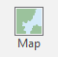
Note, this can also be done by navigating to All Apps followed by the ArcGIS Folder. Within the ArcGIS Folder, select ArcGIS Pro.
- Create a project to host your maps by clicking on Map icon.
- The Create a New Project window should be shown. Define the name for your project. You can give any name that you prefer. Then click on Folder icon, find the location that you want to save your project.
- You do not need to change others.
- Click on OK.
An empty map with default background world maps should be shown. You will need to add data into the ArcGIS Pro.
- Click on Add Data button under Map tab.
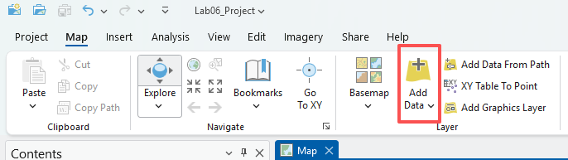
- Navigate to the location where you stored your data. Highlight county layer, click on OK.
Wait for a while, the data layers will be loaded into ArcGIS Pro. You can find them in the Contents panel.

Step 2. Check attribute table

In this exercise, you will learn how to create dot density map for population of Arkansas in 1970 and 2010. You will need the field/attribute for population in 1970 and 2010, respectively. You can check whether the layer has the fields by right-clicking on county layer. In the drop-down window, choose Attribute Table.
In the Attribute Table, the field of POP70 and POP10, represents the population in 1970 and 2010, respectively.
Explore the tables, answer the following question.

Question 1. What is the population for Faulkner County in 1970 and 2010, respectively? How does it change? (5 points)

Step 3. Display map with dot density.

- Right-click on the county layer, in the drop-down menu, click on “Symbology”.
- In the Symbology-county window, set “Dot Density” for “Primary symbology”. Select “POP70” for “Fields”.
- Click on the point under “Symbol”. In the Format Point Symbol-POP70 window, click on Properties. Select your favorite color for the dots. Click on Apply.
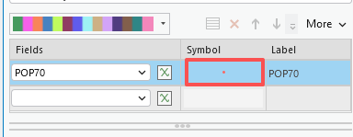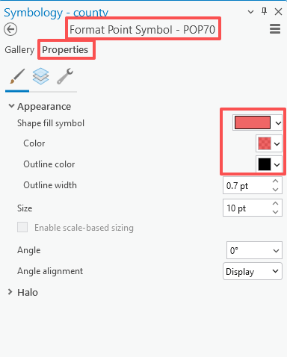
- Navigate back to the Symbology-county window by clicking on the navigation direction .
- Set “Dot Size” and “Dot Value” to the values you prefer (Please try different combinations and write them down. You will need them for your 2010 population map). You may try several times until you get good combinations.
- You do not need to change others.
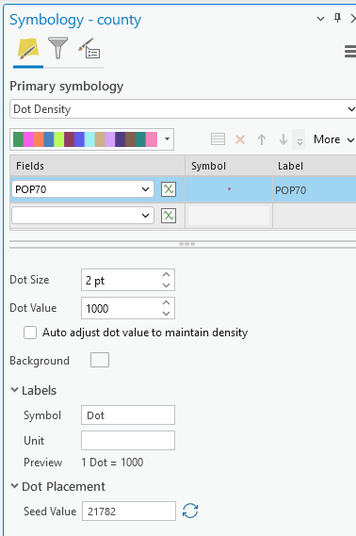
The population dot density map is generated.
Based on the map, answer the following question.

Question 2. Which regions do have relatively high and low population in 1970 in Arkansas, respectively? Are they in your expectations? (5 points)

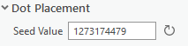
Note, the locations of dots in each county are randomly generated. If you want to generate new locations, you will need to refresh the ‘Dot Placement’ in the ‘Symbology-county’ window.
Play with the map, zoom in and out by scrolling the middle button in the mouse to see how the dot density changes.
To get the original extent, right-click on the data layer, in the drop-down window, select Zoom to Layer.

Step 4. Create a layout and share your map

You’ve learned how to create a layout in Exercise 1.
Recap:
- Navigate to the Insert Tab and Select New Layout.
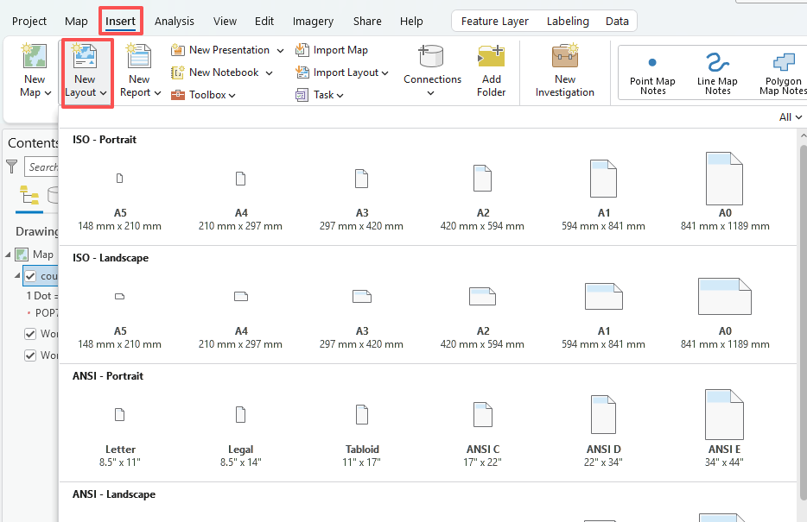
- From the list, select your preferred size. A new blank layout should be added.
- To add the map to the layout, click on Map Frame under the Insert Tab.
- In the layout, draw a rectangle in any empty space, the map you just worked should be added.
Note, your map may be too large for the frame, you can adjust it through setting the new display scale.
- Right-clicking on the map, in the drop-down menu, select Activate.
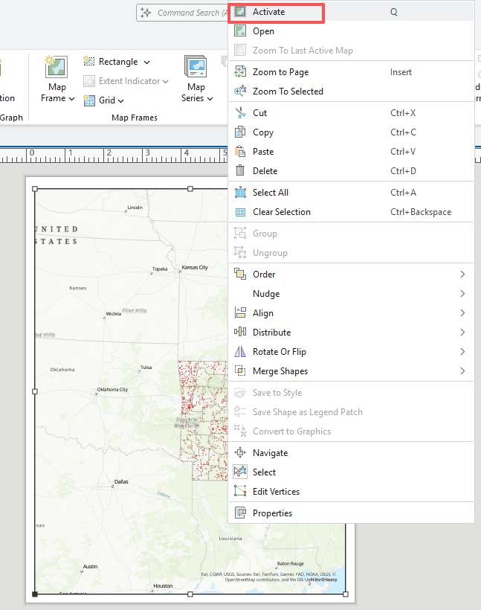
- Set the proper scale in the low-left corner scale box. Write down the scale, you will need it for your 20110 population map.
- Navigate to Layout Tab, followed Close Activation to exit the activation mode.
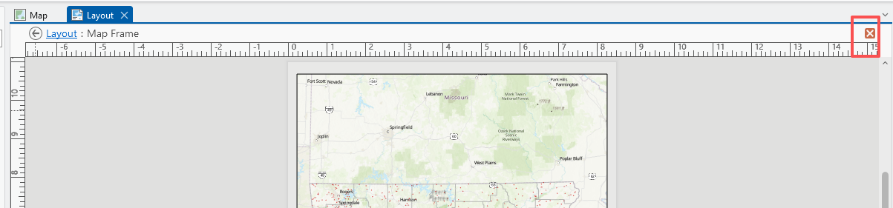
You’ve learned how to share your layout in previous exercise, you will learn more. In this exercise, you will share your map in a SVG format. The SVG format is a vector format, which can be edited in a geographic edit software. The raster format, such as PNG you learned in previous class, cannot be edited in the geographic edit software.
- Check out the box before “World Topographic Map” and “World Hillshade” to reduce the size of SVG output, as our output is already very large.
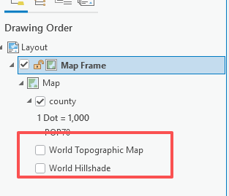
- Navigate to the Share Tab and select Export Layout.
- In the Layout window, select “SVG” for the File Type. Save the file to the location you are choosing and set the name as “Population dot density map in 1970.svg”. Check the box of “Clip to graphics extent”. Set “70” for “DPI”.
- You do not need to change others.
- Click on Export.

Deliverable 1: Submit the “Population dot density map in 1970.svg” file to Blackboard. (5 points)

Deliverable 2: Insert a New Map, repeat Steps 3-4 to generate a svg file for the population dot density in 2010 and submit it to Blackboard (6 points). (Hint, the Layout will be changed automatically along with the map. Make sure your dot size and value, and display scale are same as the 1970 map)
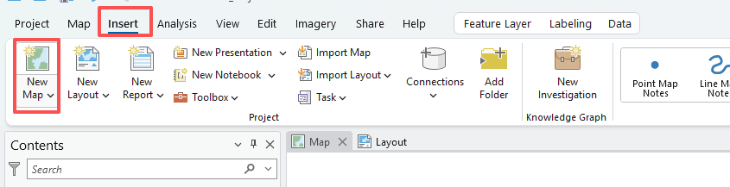

Question 3: Which regions do have relatively high and low population in 2010, respectively? Are they in your expectations? (6 points)

Step 5. Build a layout with two map frames
- Create a new layout
This time, we have two map frames, so we use Landscape.
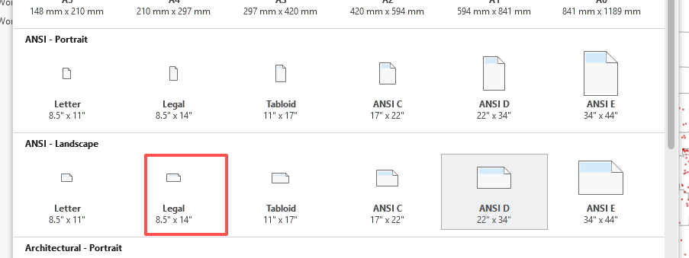
- Now you should have two map frames in the ArcGIS pro, one for population in 1970, another for population 2010. you can modify the name of the map to avoid confusion.

- Right the map, select property, select the general, change the name to ‘pop70’. Repeat this step for another map frame to change the name to ‘pop10’

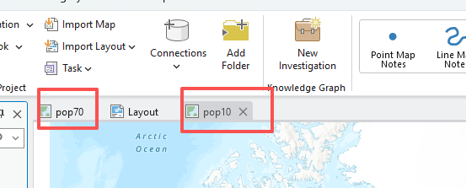
- In the new layout, Insert the first map frame (1970)
- Insert tab → Map Frame → choose pop70→ drag a rectangle on the left half of the page.
- Insert the second map frame (2010)
- Insert tab → Map Frame → choose pop10 → drag a rectangle on the right half.

- Make both frames exactly the same size & aligned
- Select the left frame, then the right (Ctrl-click for multi-select).
- Right-click the map, select properties. Select placement in multiple elements.
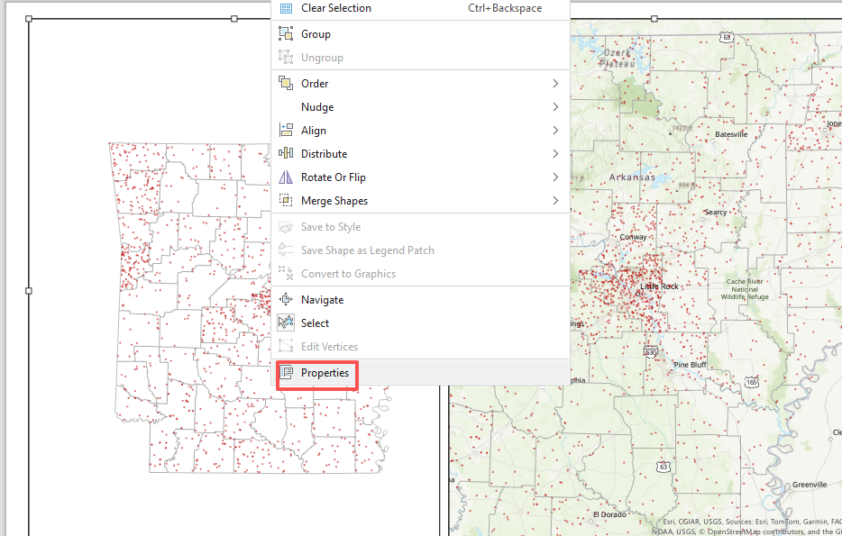

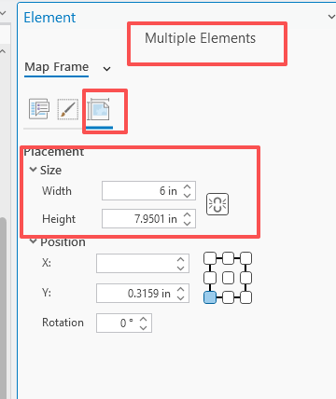
- Set the width to 6 inch, the height as 7.0inch. After setting the width and height, your two map frame should has same size.
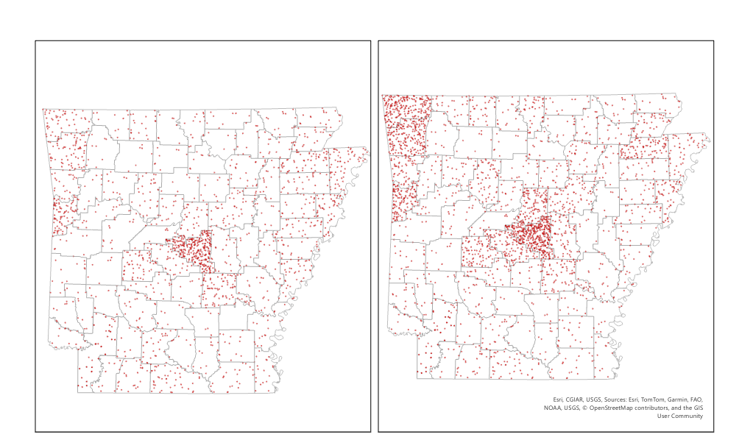

- Set the same scale for both map frames
- Click the left map frame → Layout tab → Activate.
- In the scale box (upper left of the Map ribbon), type a scale (e.g., 1:1,500,000).
- Layout tab → Close Activation.
- Click the right map frame → Activate → enter the same scale value. Pan to match the same area (or as desired).

Step 6: Titles and subtitles
Main title
- Insert tab → Text → drag a box above the maps.
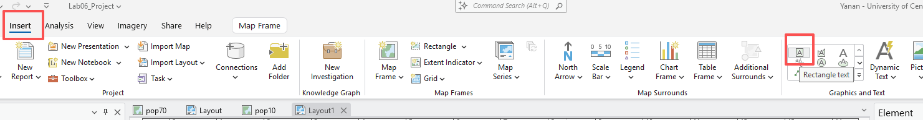
- Right-click the text box to enrich the title and modify font size.
- Type title:
Population Dot Density: 1970 & 2010
- Use the Text Symbol to set font, size, bold, and center it.
Subtitle
- Insert → Text → place above the left frame: 1970 Population.
- Insert → Text → place above the right frame: 2010 Population.

Step 7：Legends
Option 1: One shared legend (simplest if dot value is identical)
- Select either map frame (e.g., left) → Insert tab → Legend → drag a box to place the legend.
- Right-click the legend, select Convert to graphics, right-click the legend again, select ungroup. After ungroup, you have two parts in the legend.
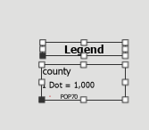
- Double click the legend, change the text to Population.
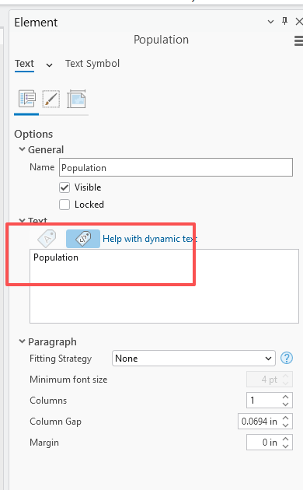
- Select the second part in the legend, right click and select ungroup again. Now the second part is divided into three parts.
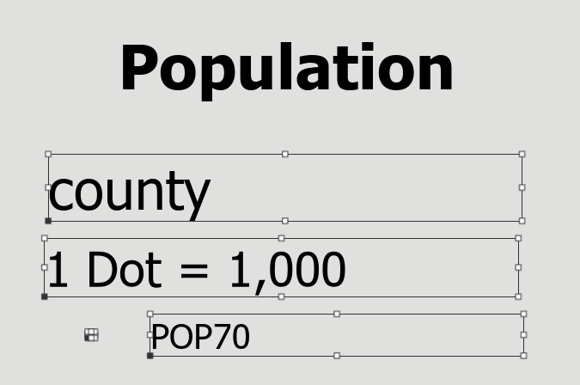
- Select POP70 and change text to Population.
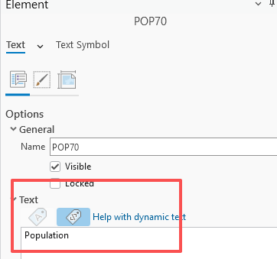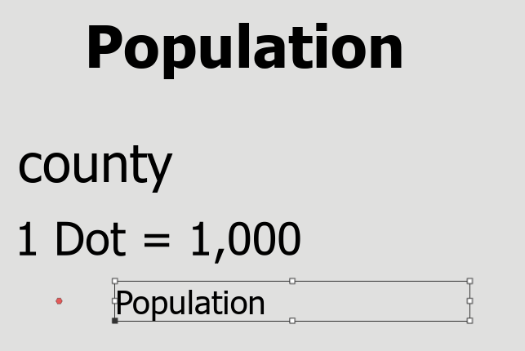
- After the modification, use mouse to select all parts, then select the group. All the parts are combined into one part again. Place the legend to the bottom of the map.
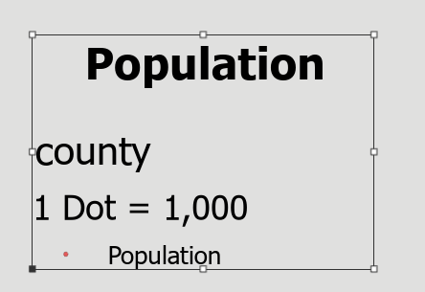
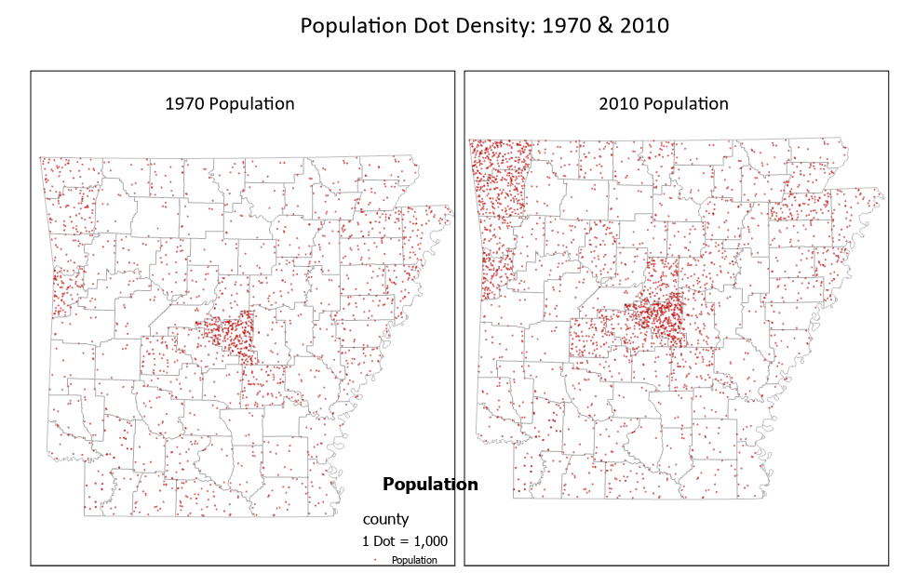
The legend is overlaid with a map border. Now let’s change the color of the map border to non-color. Select both maps, select properties. Select the display and change the border’s color to No color.
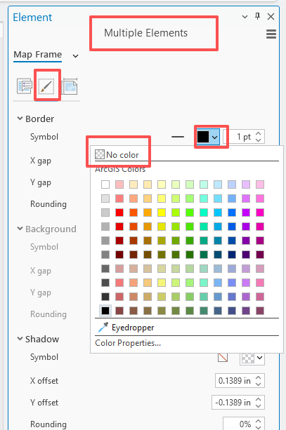
Now your two maps should look similar to the screenshot below. This is just a basic adjustment to get the layout ready. There are many additional tools you can explore to further refine and polish your map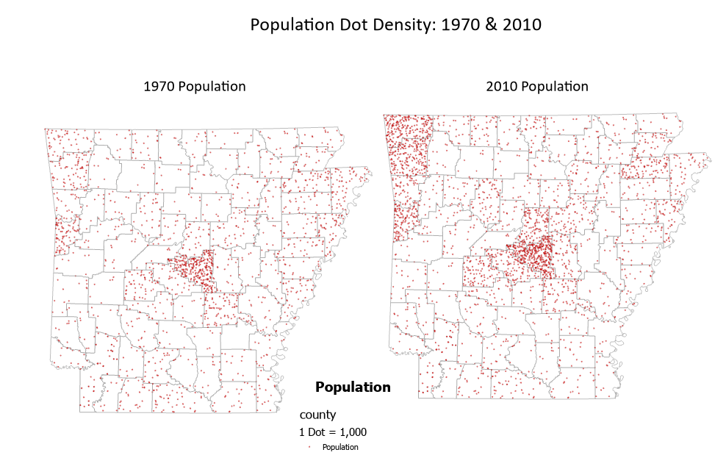

Deliverable 3: Export your map with two population density as .jpg or .png and paste here. (12 points)

END OF EXERCISE

Homework
Please submit a Word file with three questions and three deliverables through Blackboard.

